**Topics: Descriptive Statistics and Probability**

1. Look at the data given below. Plot the data, find the outliers and find out $μ, σ, σ^{2}$

|  |  |
| --- | --- |
| **Name of company** | **Measure X** |
| Allied Signal | 24.23% |
| Bankers Trust | 25.53% |
| General Mills | 25.41% |
| ITT Industries | 24.14% |
| J.P.Morgan & Co. | 29.62% |
| Lehman Brothers | 28.25% |
| Marriott | 25.81% |
| MCI | 24.39% |
| Merrill Lynch | 40.26% |
| Microsoft | 32.95% |
| Morgan Stanley | 91.36% |
| Sun Microsystems | 25.99% |
| Travelers | 39.42% |
| US Airways | 26.71% |
| Warner-Lambert | 35.00% |

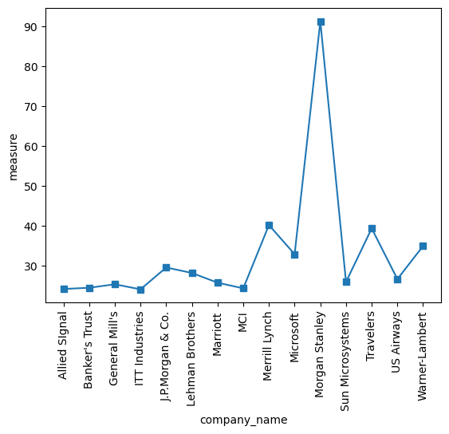

A)Mean=33.20466666666667

B)standard deviation=16.40420387854555

c)variance=269.0979048888889



Answer the following three questions based on the box-plot above.

1. What is inter-quartile range of this dataset? (please approximate the numbers) In one line, explain what this value implies.
2. What can we say about the skewness of this dataset?
3. If it was found that the data point with the value 25 is actually 2.5, how would the new box-plot be affected?

**Answer:**

1. The quartile range of the data set of given box plot are Q1 is around 5 and

Q3 is around 12 so IQR=Q3-Q1=7

ii) the box plot are data distribution of right skewed and most of the data are located near Q1 .

iii)If the value of 25 is actually 2.5 …the value will be on the left side of the boxplot and will not be considered as outliers…. Most of the value are in right side as consider as outlier. The mean of 22.5 from above plot the distribution is approximate till 20.so there is no outlier in the distribution.



Answer the following three questions based on the histogram above.

1. Where would the mode of this dataset lie?
2. Comment on the skewness of the dataset.
3. Suppose that the above histogram and the box-plot in question 2 are plotted for the same dataset. Explain how these graphs complement each other in providing information about any dataset.

**Answer:**

1. The mode of the data set lie on the between the range of 5 to 7 in approximate. the histogram is bimodal distribution.

ii) The histogram of distribution of the data set is right skewed .

iii) From the Q2 Boxplot and this histogram, the distribution is same ….it is same type of skewness is reflecting and the right side of skewness and right side distribution of outliers but approximately show mode as 5-7 and median around 7. So it is more compliments to both plots

1. AT&T was running commercials in 1990 aimed at luring back customers who had switched to one of the other long-distance phone service providers. One such commercial shows a businessman trying to reach Phoenix and mistakenly getting Fiji, where a half-naked native on a beach responds incomprehensibly in Polynesian. When asked about this advertisement, AT&T admitted that the portrayed incident did not actually take place but added that this was an enactment of something that “could happen.” Suppose that one in 200 long-distance telephone calls is misdirected. What is the probability that at least one in five attempted telephone calls reaches the wrong number? (Assume independence of attempts.)

**Answer**:

Here total calls =200, one call is misdirected and others are right

p(success)=1/200

q(failure)=199/200

n(samples)=5

x(failure)=atleast 1

For Probability of an event=P(x)= ${{}_{}^{n}C}_{x}$ $P^{x}$ $Q^{(n-x)}$

**

Here P (at least 1 failure out of 5 calls) + P (no failure calls) = 1 ……… (Total Probability=1) -------(1)

=> P (at least 1 failure out of 5 calls) = P (1) + P (2) + P (3) + P (4) + P (5)

=> P (no failure calls) = P (0)

From equation 1,

Hence P (at least 1 failure out of 5 calls) = 1 - P (no failure calls)

= 1 - ${{}_{}^{5}C}_{0}$ ${(\frac{1}{200})}^{(0)}$ ${(\frac{199}{200})}^{(5-0)}$

**

= 1 – (1*1*0.975248)

= 0.024752.

Hence the at least 1 failure out of 5 calls =0.024752

1. Returns on a certain business venture, to the nearest $1,000, are known to follow the following probability distribution

|  |  |
| --- | --- |
| x | P(x) |
| -2,000 | 0.1 |
| -1,000 | 0.1 |
| 0 | 0.2 |
| 1000 | 0.2 |
| 2000 | 0.3 |
| 3000 | 0.1 |

1. What is the most likely monetary outcome of the business venture?

**Answer:**

The monetary outcomes of the business venture $2000 is having the most probability

Distribution is 0.3. it is the most likely monetary outcome of the business venture.

1. Is the venture likely to be successful? Explain

**Answer**

order for a venture to be successful…. We must compute the probability …i.e.,

Difference of Positive and negative return probability….

And the venture will be only successful only when the Positive probability is positive…

To be calculate positive in given table:

* (0.2+0.2+0.3+0.1)
* 0.8

venture is 80% probability to be successful.

1. What is the long-term average earning of business ventures of this kind? Explain

**Answer:**

Long time average can be calculated probabilities multiplied by its own return

* (1000*0.2) +(2000*0.3) +(3000*0.1) +(-2000*0.1) +(-1000*0.1)
* 800, which clearly shows in a given period …
* profit or loss the final outcomes returns calculated for one year
* The final computation of period shows the venture is having a 600 profit a month.

1. What is the good measure of the risk involved in a venture of this kind? Compute this measure

**Answer:**

The good measure of risk involved in venture of this kid

And that deviation can be measured by standard deviation

Here, mean $\overline{X}$ = 600

Variance= (${(-2000-600)}^{2}$*0.2 + ${(-1000-600)}^{2}$*0.1 + ${(0-600)}^{2}$*0.2 + ${(1000-600)}^{2}$*0.2 + ${(2000-600)}^{2}$*0.3 + ${(3000-600)}^{2}$*0.1)/6

Variance= 2160000

Std.Deviation= $\sqrt{Variance}$

=1469.69, this is the period of the risk from other in the venture.